Axa Uribe Carazas

WDD 130-02

Apr 1st, 2023

*Final Project: Personal Page*

DREAMWORK

1. COMPONENTS
2. Homepage: <http://127.0.0.1:5500/Personal_Site/Official%20Page/homepage.html>
3. Programs: <http://127.0.0.1:5500/Personal_Site/Official%20Page/page2.html>
4. Covenants: <http://127.0.0.1:5500/Personal_Site/Official%20Page/page3.html>
5. SUBJECT

My website introduces an educative theme. I have been interested in education for a long time. The educational system worldwide needs more essential tools and techniques. I support active learning; many studies have shown that knowledge is better retained through practice than other learning strategies. Due to this fact, it is reasonable for companies to look for experienced people when hiring. However, many professionals and applicants sometimes find themselves in complicated situations when they find out that the requisites to apply for jobs are entirely ridiculous, and frustration arrives. University degrees sometimes are unnecessary for many job fields now; we live in the era of globalization, and almost all the information is online. So, the website's main idea is to provide cyberspace for students who want to acquire experience in specific job fields without a certificate or previous experience. This website will contact them with companies willing to teach them about themselves and look for future talents.

1. AUDIENCE

For sure, my central public is students, starting from Elementary School through to University students. You maybe wonder how Elementary Students can get experience for future jobs. Well, in this case, we want to focus on courses. These courses are not based on theory but on projects in which they can participate, accompanied by other students according to their respective ages and interests. So, they can capacitate on specific topics adding learning that prepares them to participate in actual work projects when they advance on levels.

1. OBJECTIVE

I know it is a website that is just essential for front-end development. Still, in the future, when I acquire more learning, I would love to implement the actual website among schools in collaboration with companies interested in contributing to education and job experience among young people.

1. PROCESS OF DESIGN

I love to design in general! Websites, logos, presentations, everything! For this website, I created the wireframe using Figma. Honestly, before, I had used Canva for everything, but I enjoyed using Figma, and it felt nice; I could see how the code was supposed to go in the CSS, which is one of my favorite tools inside Figma. And by the way, I learned to use this in a workshop provided by a student at school. Specifically, I created the whole wireframe in one day and 6 hours. And I know it is too much, but that was my first time using Figma seriously; I just attended one lesson. And let’s add that I am a kind of a perfectionist. I am not satisfied with the result yet, but I am glad about the draft. In addition, the code part was different stuff, I did not take that long, but the most challenging part was when you moved something, and everything was messed up. So, that took me a considerable time. It is not the same as the wireframe, but I consider it a good product.

1. ORIGINAL WIREFRAME

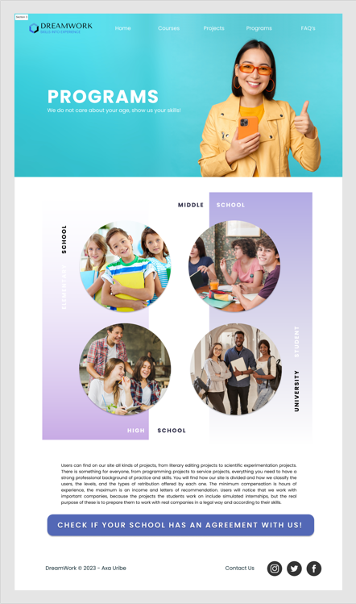

1. CONCLUSION

I expect this to become a big future project. Just imagine having students around the globe sharing experiences and interchanging knowledge, improving their skills. It will be a fantastic event!